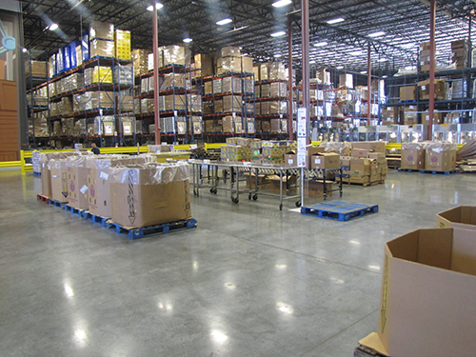
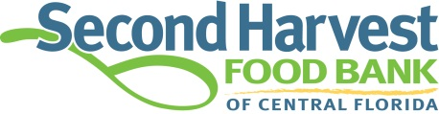
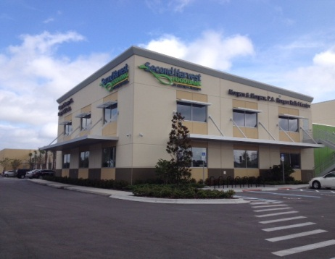

Investment & Impact Update – May 2014
More Food / More Volunteers / More People Fed / More Efficiently
J
ust over a year has passed since we’ve been in the new Morgan & Morgan Hunger Relief Center. Your investment is paying off in major ways. We wanted to provide you with some highlights on the Return On Investment, it’s impressive. Operational efficiencies are being realized, more people are getting engaged in the cause, entrepreneurial activity and revenue is happening and most important, more people are getting more food. We promised advancements like these and are pleased to provide you with some highlights that show the difference in impact vs. our previous facilities.

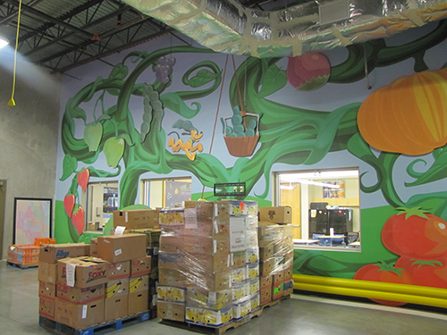
Thank you for making this possible!

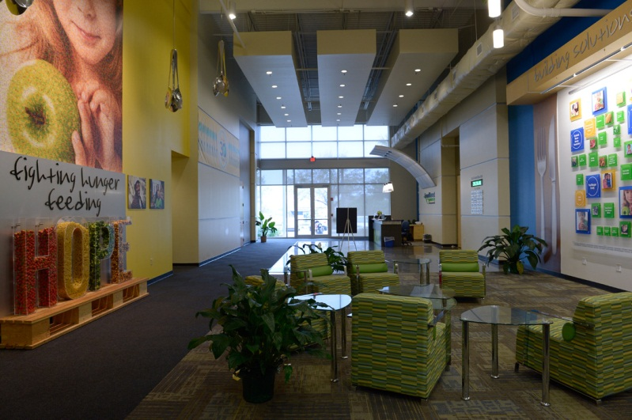

April 2013 – April 2014: Year #1
- Return on Investment
  - A ROI of 750% is being realized. When you compare the in-kind value of the food being distributed against the operational expenses, a great return results.

- Impact
  - Food distribution is up 26% over the same period last year
    - That is equivalent to an additional 5.6 million meals, exceeding our projections
    - Total annual distribution was just over 33 million meals.
      - In-kind retail value of over $100 million
      - If you gave every person in the Amway Center sell-out crowd a meal,
we would fill the place 1,754 times
- Nutrition: Fresh fruits and vegetable distribution is up 30%
- Equivalent to an additional 60 tractor trailer loads
- The Publix Repack Area and expanded cooler capacity makes this possible

- Volunteers
- The Disney Volunteer areas are bringing in many more volunteers that previously had to be turned away due to lack of capacity.
  - We set a 30 year record:
    - Over 59,000 volunteer hours, an increase of 21,000 hours
    - In kind value of time: $1.2 million
- Partner Agency Service
- The Dr. Phillips Charities Agency Mart makes it possible for:
  - 10 -12 additional agency appointments per day
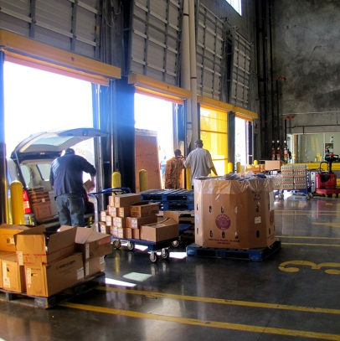
    - More agencies and more frequent pickups result
    - More new agency applications are possible because
of the increased capacity of the Agency Mart
    - Faster Agency checkout
    - Reserved parking area for Agencies and more loading docks all translate into more food flowing like never before

- The Every Kid Outreach Agency Lobby
- Partner agency networking abounds

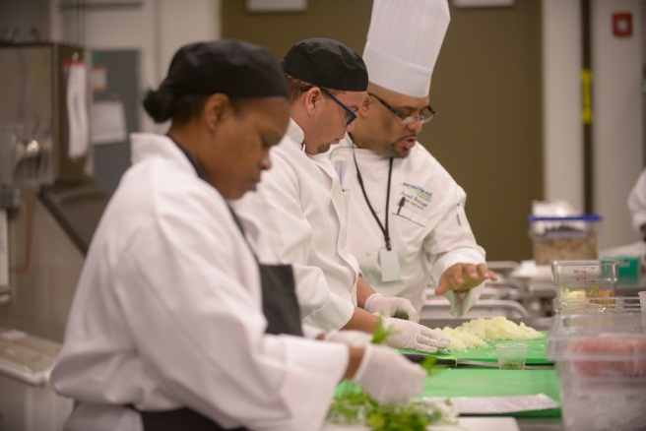
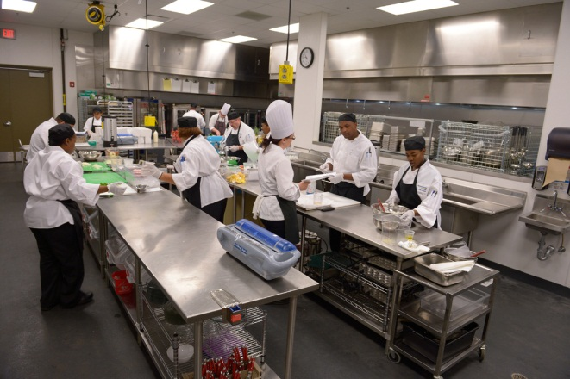

- Darden Community Kitchen
- The kitchen is currently hosting its fourth class of students; lives are being changed, success stories are adding up.
  - A waiting list of interested applicants due to popularity and demand
- All graduates were placed into jobs paying well over the minimum wage
- We have a 100% job placement rate at graduation

- The Morgridge Family Foundation Kitchen Classroom
- The Kitchen students are learning life skills as well as culinary skills.
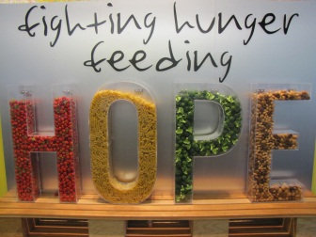
  - Collaboration with Goodwill Industries, WorkForce Central Florida and the Jobs Partnership provide the life skill training
  - Innovative financial literacy classes are being taught in conjunction with Red and Black Books.
  - Basic foodservice finances and business practices also being taught by visiting restaurateurs
- Efficiency
- Our cost to distribute one pound of food has been reduced by 60%...leveraging your investment.
- New Technology is resulting in increased benefits in terms of cost and time savings:
- Bar code scanning of inventory results in faster and more accurate tracking.
- Our inventory is “real time’ and available to Partner Agencies for on-line ordering resulting in enhanced service and convenience.
- Our fleet of 19 trucks and the GPS Routing System is cutting our annual mileage by over 40,000 miles. Every diesel dollar saved equates into more food being distributed.
- Higher Operational Standards in place – due to the new facility, we received a “Superior Rating” on our food industry audit by AIB. They are the gold standard auditing company for the food industry. We scored 925 points out of a possible 1,000 – extremely rare in the food distribution business. Almost unheard of in the non-profit world.

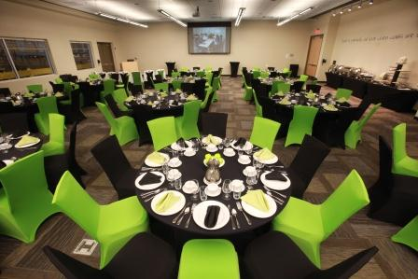

- Engaging More of the Public / Social Entrepreneurism / Innovation
- Our venue space that includes our Community Room and the Bank of America Boardroom has drawn 140 different groups and thousands of people to the new facility. The groups consist of a combination of non-profit, corporate and government. We are able to generate revenue from the venue rentals as well as thousands of meals that have been provided by the students in Darden Community Kitchen.
- This coming year we will be expanding our catering. Evenings and weekends will be added along with a revised menu of offerings for various budget levels and tastes.
- We are busy providing tours for people from around the country that have heard of the unique vision of our new facility and its impact.
- We just received the NAIOP Commercial Real Estate annual award for “Development of the Year”. We received this award through CNL, our project manager for this amazing facility.

- Moving Forward
- We want to close out the capital campaign and fully leverage this powerful new asset for the Central Florida community. Please consider telling others of this success story and open doors for us to have the opportunity to meet potential investors. We are close!
- The link below leads you to a five minute inspirational video on the new facility:
http://www.youtube.com/watch?v=BXSFhOF0C8o

www.feedhopenow.org

