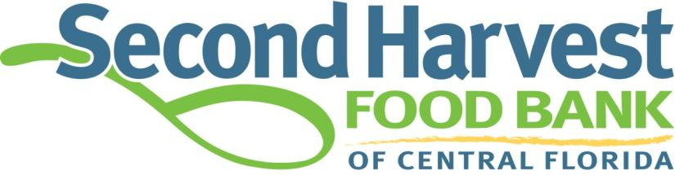

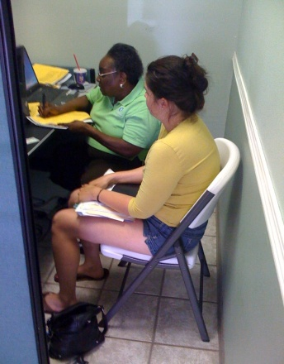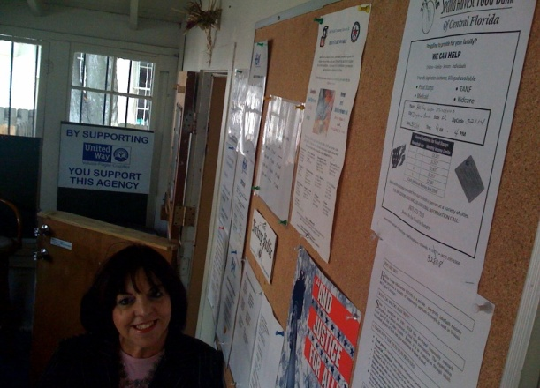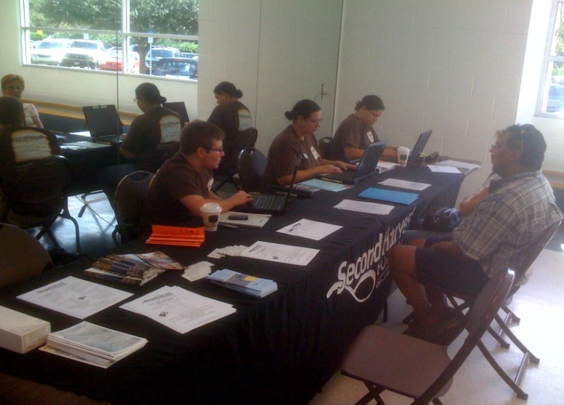

Benefits Connection Update
3/11/2010

- Six County coverage with 9 Outreach Specialists, Manager and Admin. Assistant
- Federal Demonstration Project (conducting the final client interview)
  - Six-Month Evaluation just completed with positive results:
    - Clients are receiving benefits in half the time as compared to State average
    - Application approval rate for SHFB: 80% vs. 66% for the State
    - 100% accuracy rate for SHFB
    - 96.4% timeliness rate for SHFB vs. 78% for the State
    - 98% of applicants very satisfied with SHFB service
    - DCF is recommending to the federal government to expedite demo approval for remainder of State.
- Food Stamp value generation: Year 1 = $4.1 million / Year 2 on track for $11 million
- Average monthly dollar value for SHFB: $223 vs. $87 for the State
- Dr. Phillips challenge match to be completed by March 31
- Federal government 50% match continues – over $200,000 to date
- EITC collaboration: Offering outreach services at tax prep sites and distributing EITC information to all applicants
- KidCare collaboration: Handling referrals and encouraging families to apply for KidCare
- Brevard County:
  - Additional Specialist added through Brevard United Way funding and Alzheimer’s Foundation and Community Services Council
  - Two additional Specialists to be added through Brevard United Way collaboration with the use of surplus TANF ARRA funding
- Florida Philanthropic Network Annual Summit: Presented with DCF and Winter Park Health Foundation on “Effective Cross-Sector Partnerships”.
- Hosted a visit for USDA Food and Nutrition Services, National office. Lisa Pino, USDA Deputy Administrator and Don Arnett, Southeast Regional Director for USDA and local DCF execs.
- Continue to Co-Chair a State-wide group for DCF Secretary Sheldon regarding public benefits

BC311update

